Project 1
CS 557 - Computer Graphics Shaders
Name: Tianle Yuan (933-946-576)
Project Number: 1
Project Name: Step- and Blended-edged Elliptical Dots
Video Link: https://media.oregonstate.edu/media/t/1_uicblon7
Email: yuant@oregonstate.edu
Time: January 12, 2020

Screen Captures：
As I open the project 1, we can see the cat with Hard-edged elliptical dots:
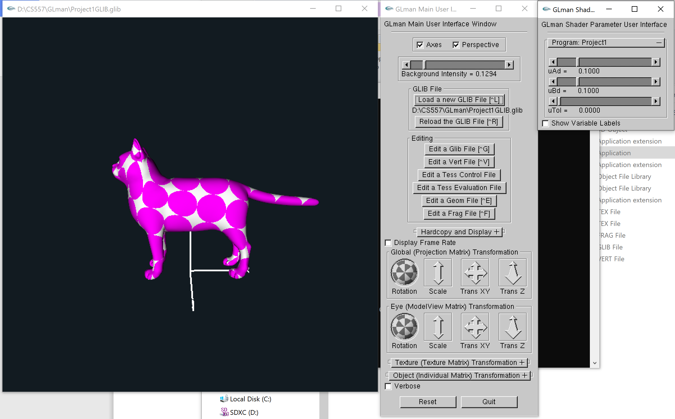

Changing the variable UTol, we can get smooth-edged elliptical dots:
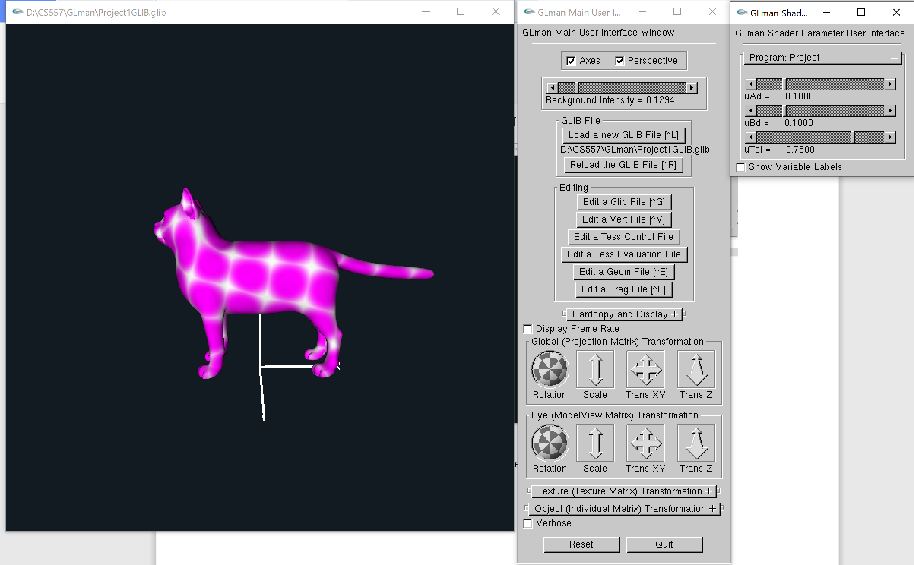
For “Correct elongation”, we can change the value of variable uAd and uBd:
For bigger uAd and uBd value:
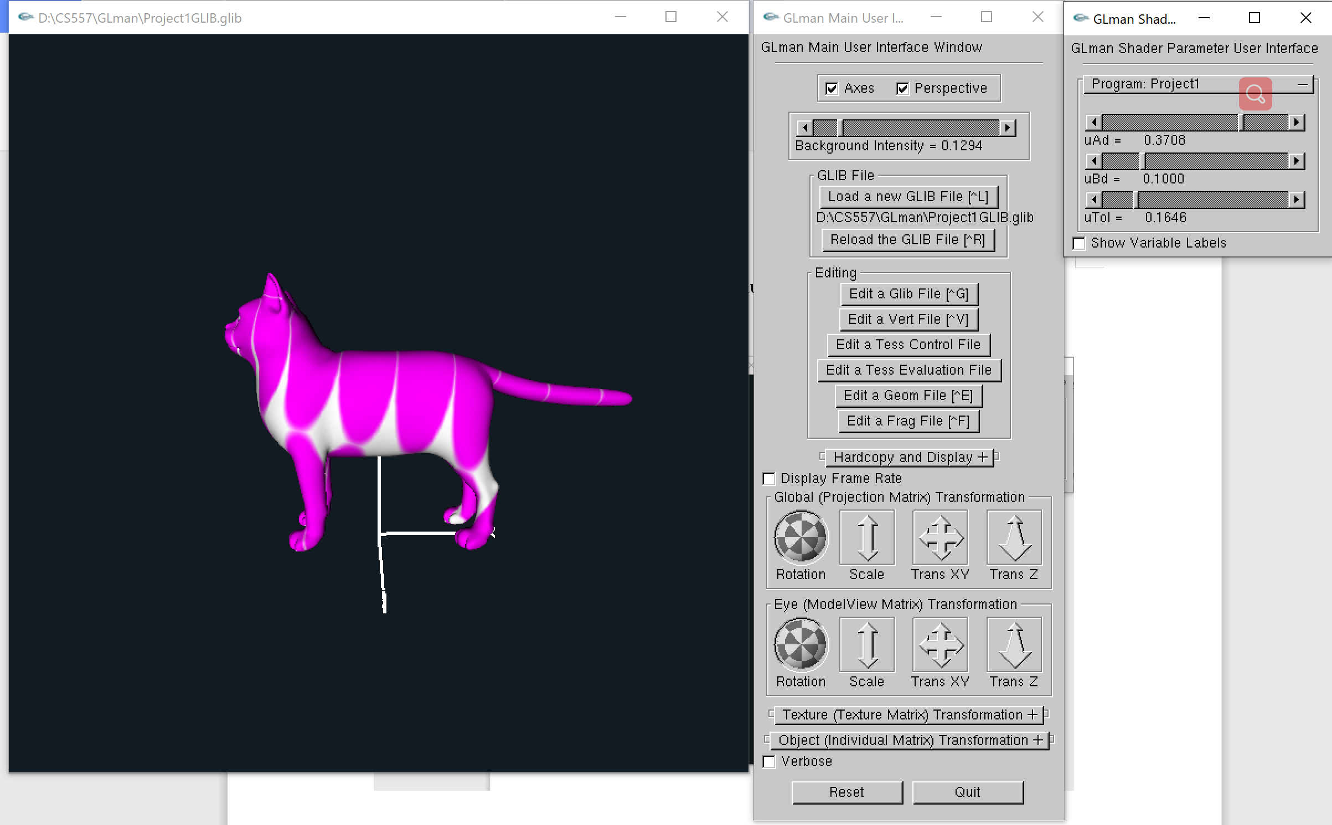
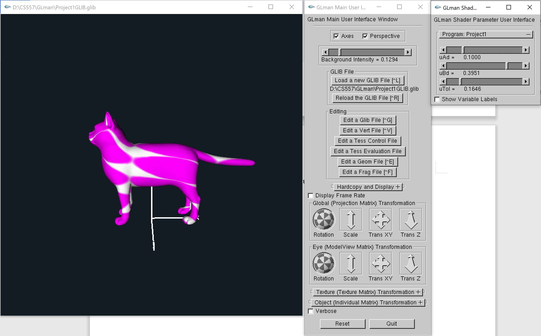

For smaller uAd and uBd value:
